**Algorithm Analysis for Industrial Robotics Applications: A Comprehensive Comparison**

Based on extensive research into current applications and performance benchmarks in industrial robotics, this analysis evaluates six prominent algorithms across three critical tasks in automated manufacturing environments. The comparison reveals significant differences in algorithm suitability, computational requirements, and practical implementation considerations.[1][2][3][4]

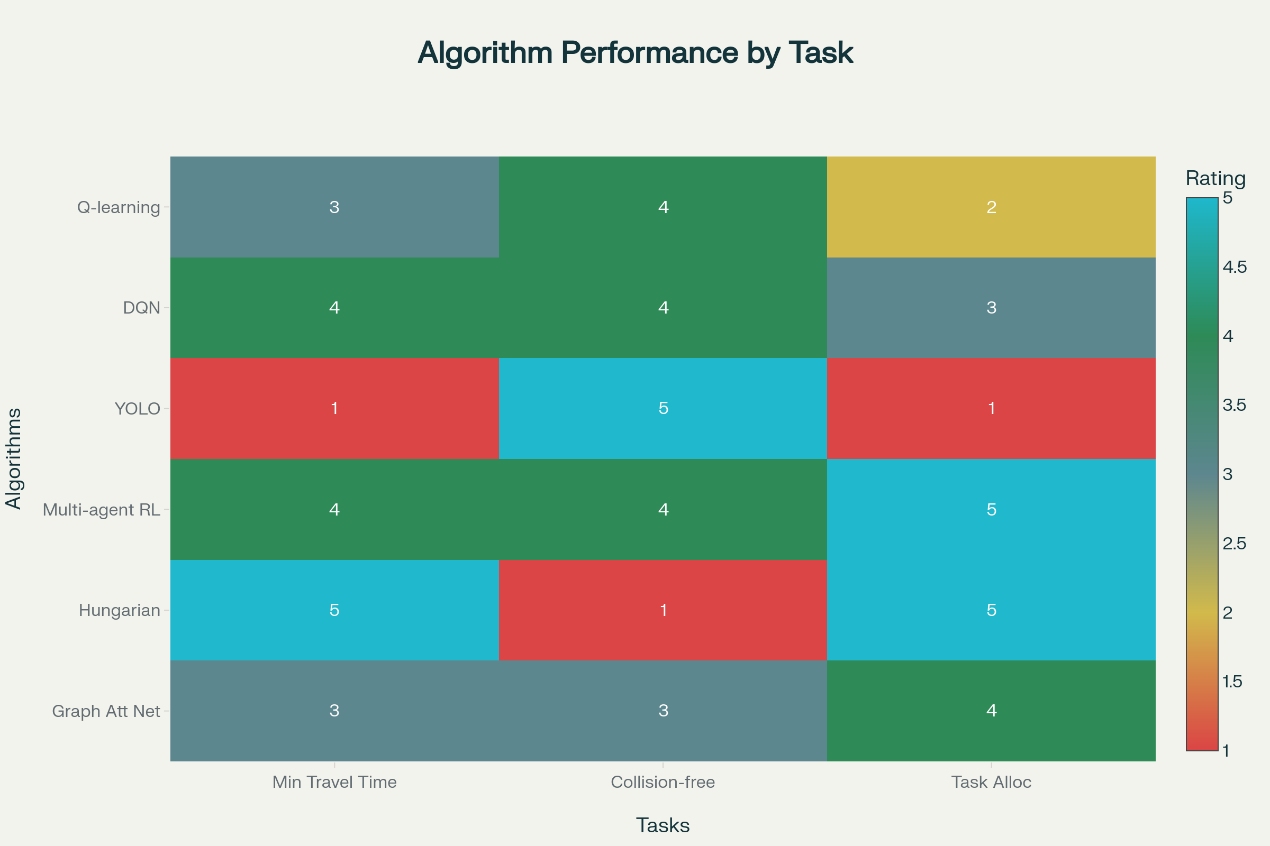

Algorithm Performance Comparison for Industrial Robotics Tasks

**Task 1: Minimize Travel Time and Path Length for Efficient Material Transport**

**Hungarian Algorithm - Optimal Performance**

The Hungarian algorithm emerges as the superior choice for minimizing travel time and path length in material transport scenarios. This combinatorial optimization algorithm solves assignment problems in polynomial time with O(n³) complexity, making it exceptionally well-suited for optimizing resource allocation and minimizing total costs. In industrial applications, the algorithm consistently delivers optimal solutions when assigning multiple robots to transportation tasks, achieving up to 34% better performance compared to basic genetic algorithms in real-world manufacturing scenarios.[5][6][7][8]

**Performance Metrics:**

* **Path Optimality**: Guarantees globally optimal solutions for task assignments
* **Computational Efficiency**: O(n³) time complexity with deterministic results
* **Industrial Applications**: Proven effective in smart manufacturing with limited buffer constraints[8]

**Deep Q-Network (DQN) - Strong Alternative**

DQN demonstrates significant advantages in path planning applications, particularly in dynamic environments where traditional algorithms struggle. Research shows DQN-based approaches achieve 19.39% reduction in average planning time and 5% reduction in path length compared to standard RRT*-Connect algorithms. The algorithm excels at learning optimal policies through trial-and-error, making it adaptable to changing manufacturing conditions.[9][10][11][12]

**Key Advantages:**

* **Adaptability**: Learns from environmental changes and improves over time
* **Real-time Performance**: Effective for online path planning in industrial settings[10]
* **Multi-objective Optimization**: Balances multiple factors including makespan and energy consumption[11]

**Multi-Agent Reinforcement Learning - Coordinated Optimization**

Multi-agent RL approaches show promising results for coordinated material transport, with recent studies demonstrating up to 16% higher picking rates in multi-robot coordination tasks. The Loc-FACMAC algorithm achieves up to 108% performance improvement over baseline methods when locality structures are properly defined.[13][14]

**Performance Benefits:**

* **Coordination Efficiency**: Superior performance in multi-robot scenarios
* **Scalability**: Maintains effectiveness with increasing robot numbers
* **Dynamic Adaptation**: Handles unexpected events and system changes[15]

**Task 2: Ensure Collision-Free Navigation in Dynamic Industrial Environments**

**YOLO Model - Leading Computer Vision Solution**

YOLO-based systems demonstrate exceptional performance in collision avoidance applications, achieving 92.6% accuracy across all object classes and 95% [email protected] in real-time obstacle detection. The YOLOv5 implementation in mobile robots shows perfect recognition rates (1.00) for static objects like chairs and demonstrates superior performance compared to YOLOv4 in terms of both accuracy and processing speed.[16][17]

**Technical Specifications:**

* **Real-time Processing**: Capable of processing camera feeds at high frame rates
* **Detection Accuracy**: Achieves 79% success rate with NAV-YOLO implementation[18]
* **Integration Capability**: Seamlessly integrates with ROS navigation stacks[19][18]

**Q-Learning and DQN - Reinforcement Learning Approaches**

Both Q-learning and DQN show strong performance in collision avoidance scenarios. Q-learning implementations achieve up to 41% reduction in collision probability compared to traditional methods. DQN approaches demonstrate superior convergence speed and final performance, outperforming other state-of-the-art multi-agent RL algorithms in collision avoidance tasks.[20][21][22]

**Comparative Performance:**

* **Q-learning**: Effective for structured environments with discrete action spaces
* **DQN**: Better performance in continuous action spaces and complex environments
* **Learning Efficiency**: Both algorithms show improved performance through experience replay[9]

**Multi-Agent RL - Coordinated Collision Avoidance**

Advanced multi-agent systems using MADQN with layer-based communication channels show superior performance in managing multiple robots while avoiding collisions. These systems effectively handle three key objectives: minimizing tardiness, reducing collision risks, and optimizing energy consumption.[11]

**Task 3: Optimize Task Allocation and Robot Coordination to Improve System Throughput**

**Multi-Agent Reinforcement Learning - Superior Coordination**

Multi-agent RL approaches demonstrate the highest performance for task allocation and coordination problems. Research shows MADQN implementations achieve superior performance across various layouts and problem instances, maintaining consistency in dynamic manufacturing environments. The approach effectively manages complex dependencies between jobs, machines, and robots while optimizing multiple objectives simultaneously.[11]

**Key Performance Indicators:**

* **Throughput Optimization**: Significant improvements in overall system efficiency
* **Dynamic Adaptation**: Handles job arrivals and workstation unavailabilities effectively
* **Scalability**: Maintains performance across different problem sizes[11]

**Hungarian Algorithm - Optimal Task Assignment**

The Hungarian algorithm provides optimal solutions for task assignment problems, consistently achieving minimum total costs in allocation scenarios. In manufacturing applications, the algorithm ensures each robot is assigned to tasks that minimize overall completion time and resource utilization.[5][6]

**Optimization Benefits:**

* **Guaranteed Optimality**: Mathematical proof of optimal solutions
* **Deterministic Results**: Consistent performance across multiple runs
* **Industrial Validation**: Proven effectiveness in real manufacturing scenarios[8]

**Graph Attention Networks - Advanced Coordination**

GAT-based approaches show promising results in multi-robot coordination, particularly when combined with distributed optimization techniques. Research demonstrates that attention mechanisms can improve robot coordination by allowing selective communication and focusing on relevant information during task execution.[23][24]

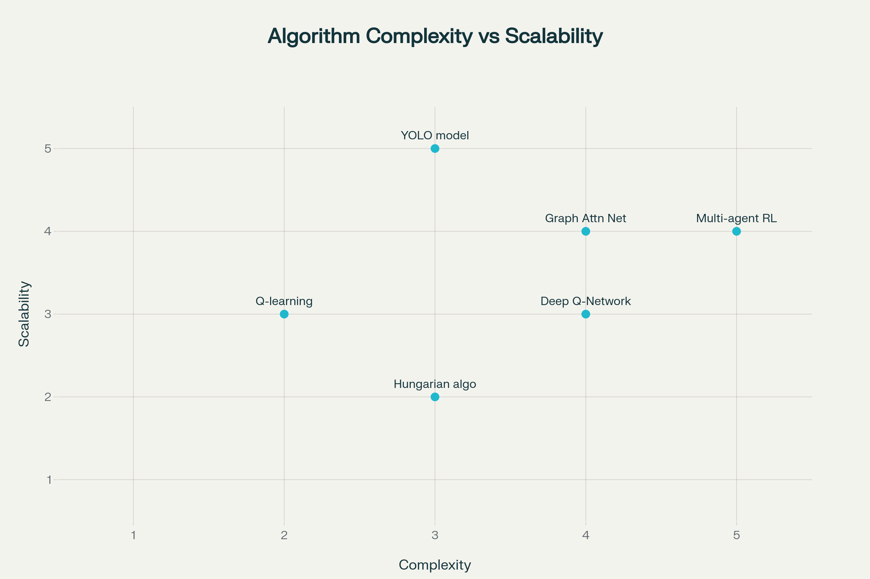

Computational Complexity vs Scalability Trade-offs for Industrial Robotics Algorithms

**Computational Complexity and Implementation Considerations**

The computational requirements vary significantly across algorithms, creating important trade-offs between optimality and real-time performance. Hungarian algorithm offers polynomial-time guarantees with O(n³) complexity, making it suitable for medium-scale problems. Multi-agent RL approaches require substantial training time but offer excellent runtime performance once deployed. YOLO models balance computational efficiency with high accuracy, making them ideal for real-time applications.[16][11][17][7]

**Recommendations by Task Priority**

**For Travel Time Optimization**: Hungarian algorithm provides optimal solutions with reasonable computational requirements, making it the primary recommendation for static task assignment scenarios.[5][8]

**For Collision Avoidance**: YOLO-based systems offer the best combination of accuracy and real-time performance, particularly when integrated with traditional path planning algorithms.[16][18][17]

**For Multi-Robot Coordination**: Multi-agent reinforcement learning approaches provide superior performance in complex, dynamic environments where multiple objectives must be balanced simultaneously.[11][13]

**Hybrid Approaches**: The most effective industrial implementations combine multiple algorithms, such as YOLO for perception, DQN for individual robot decision-making, and Hungarian algorithm for global task optimization.[25][26]

This analysis demonstrates that no single algorithm dominates across all tasks, necessitating careful selection based on specific application requirements, computational constraints, and performance objectives. The integration of multiple complementary approaches often yields the best results in practical industrial implementations.[27][28]

⁂

1. <https://linkinghub.elsevier.com/retrieve/pii/S0921889024002069>

1. <https://link.springer.com/10.1007/s11370-024-00544-3>

1. <https://linkinghub.elsevier.com/retrieve/pii/S0921889024001143>

1. <https://journal.umy.ac.id/index.php/jrc/article/view/18777>

1. <https://www.geeksforgeeks.org/dsa/hungarian-algorithm-assignment-problem-set-1-introduction/>

1. <https://byjus.com/maths/hungarian-method/>

1. <https://en.wikipedia.org/wiki/Hungarian_algorithm>

1. <https://www.nature.com/articles/s41598-024-84240-3>

1. <https://www.iterate.ai/ai-glossary/how-does-deep-q-network-dqn-work>

1. <https://pmc.ncbi.nlm.nih.gov/articles/PMC10938367/>

1. <https://arxiv.org/html/2411.00728v1>

1. <https://www.nature.com/articles/s41598-025-87113-5>

1. <https://arxiv.org/abs/2503.18816>

1. <https://arxiv.org/html/2409.13511v1>

1. <https://arxiv.org/abs/2305.17198>

1. <https://journal.umy.ac.id/index.php/jrc/article/view/25856>

1. <https://etasr.com/index.php/ETASR/article/view/10135>

1. <https://www.ijmerr.com/2024/IJMERR-V13N2-219.pdf>

1. <https://pmc.ncbi.nlm.nih.gov/articles/PMC12031456/>

1. <https://ieeexplore.ieee.org/document/9834186/>

1. <https://www.sciencedirect.com/science/article/pii/S1568494623007913>

1. <https://ieeexplore.ieee.org/document/10301527/>

1. <http://kth.diva-portal.org/smash/get/diva2:1985733/FULLTEXT01.pdf>

1. <https://arxiv.org/html/2503.21548v1>

1. <https://arxiv.org/abs/2101.06248>

1. <https://www.sciencedirect.com/science/article/pii/S2405844024159579>

1. <https://www.awerobotics.com/machine-learning-techniques-for-robot-navigation/>

1. <https://www.azorobotics.com/Article.aspx?ArticleID=727>

1. <https://pmc.ncbi.nlm.nih.gov/articles/PMC11754615/>

1. <https://publica.fraunhofer.de/bitstreams/4f84cd29-bc10-4719-b4e0-9367391816fc/download>

1. <https://onlinelibrary.wiley.com/doi/10.1155/2022/2538220>

1. <https://www.sciencedirect.com/science/article/pii/S0921889024000137>

1. <https://arxiv.org/html/2407.08534v1>

1. <https://sensors.myu-group.co.jp/sm_pdf/SM3647.pdf>

1. <https://www.sciencedirect.com/science/article/pii/S2405896321007874>

1. <https://www.sciencedirect.com/science/article/abs/pii/S1568494621005238>

1. <https://ijcrt.org/papers/IJCRT2008472.pdf>

1. <https://www.ultralytics.com/glossary/reinforcement-learning>

1. <https://library.fiveable.me/key-terms/introduction-industrial-engineering/task-allocation-algorithms>

1. <https://ieeexplore.ieee.org/document/9517332/>

1. <https://ieeexplore.ieee.org/document/7419012/>

1. <http://ieeexplore.ieee.org/document/7989659/>

1. <https://ieeexplore.ieee.org/document/9384148/>

1. <http://ieeexplore.ieee.org/document/4209603/>

1. <http://link.springer.com/10.1007/978-3-642-00312-7_23>

1. <https://ieeexplore.ieee.org/document/9831492/>

1. <https://www.frontiersin.org/articles/10.3389/fnins.2021.667011/full>

1. [https://asmedigitalcollection.asme.org/IMECE/proceedings/IMECE2018/52033/Pittsburgh, Pennsylvania, USA/289711](https://asmedigitalcollection.asme.org/IMECE/proceedings/IMECE2018/52033/Pittsburgh,%20Pennsylvania,%20USA/289711)

1. <https://onlinelibrary.wiley.com/doi/10.1002/rob.22332>

1. <https://arxiv.org/abs/2105.01777>

1. <https://arxiv.org/pdf/2203.03092.pdf>

1. <https://pmc.ncbi.nlm.nih.gov/articles/PMC10934465/>

1. <https://arxiv.org/html/2503.03509v1>

1. <https://pmc.ncbi.nlm.nih.gov/articles/PMC10933867/>

1. <https://www.mdpi.com/1424-8220/24/5/1422/pdf?version=1708599564>

1. <https://journals.sagepub.com/doi/pdf/10.1177/1729881416663663>

1. <http://arxiv.org/pdf/1707.01888.pdf>

1. <https://ijet.pl/index.php/ijet/article/view/10.24425-ijet.2023.147699/1179>

1. <https://www.kavrakilab.org/publications/moll-sucan2015benchmarking-motion-planning.pdf>

1. <https://arxiv.org/pdf/2509.02146.pdf>

1. <https://www.clear.rice.edu/comp450/papers/crc_book_chapter10.pdf>

1. <https://informatica.si/index.php/informatica/article/viewFile/8515/4439>

1. <https://pmc.ncbi.nlm.nih.gov/articles/PMC8051283/>

1. <https://www.sciencedirect.com/science/article/pii/0885064X87900252>

1. <https://www.sciencedirect.com/science/article/pii/S0921889025002003>

1. <https://kavrakilab.org/publications/halperin-kavraki1999robot-algorithms.pdf>

1. <https://www.cureusjournals.com/articles/2894-synergistic-innovations-in-multi-robot-coordination-cutting-edge-collision-free-pathfinding-strategies-and-real-world-deployments>

1. <https://www.sciencedirect.com/science/article/pii/S259012302502403X>

1. <https://www.sciencedirect.com/science/article/abs/pii/S0957417425027769>

1. <https://ieeexplore.ieee.org/document/10786425/>

1. <https://ieeexplore.ieee.org/document/10903616/>

1. <https://ieeexplore.ieee.org/document/9596694/>

1. <https://ieeexplore.ieee.org/document/10266145/>

1. <https://ieeexplore.ieee.org/document/10412438/>

1. <https://arxiv.org/pdf/2501.05411.pdf>

1. <https://www.emerald.com/insight/content/doi/10.1108/ACI-10-2023-0089/full/pdf?title=a-dynamic-reward-enhanced-q-learning-approach-for-efficient-path-planning-and-obstacle-avoidance-in-mobile-robotics>

1. <https://pmc.ncbi.nlm.nih.gov/articles/PMC9184183/>

1. <https://downloads.hindawi.com/journals/js/2021/4294841.pdf>

1. <https://pmc.ncbi.nlm.nih.gov/articles/PMC10222496/>

1. <https://pmc.ncbi.nlm.nih.gov/articles/PMC9371426/>

1. <https://downloads.hindawi.com/journals/cin/2022/2540546.pdf>

1. <http://arxiv.org/pdf/2412.12650.pdf>

1. <https://pmc.ncbi.nlm.nih.gov/articles/PMC11750848/>

1. <https://dx.plos.org/10.1371/journal.pone.0279438>

1. <https://www.sciencedirect.com/science/article/pii/S1568494620307341>

1. <https://www.sciencedirect.com/science/article/pii/S095741742300756X>

1. <https://arxiv.org/pdf/2209.05738.pdf>

1. <https://www.sciencedirect.com/science/article/abs/pii/S0360835223001365>

1. <https://www.reinforcementlearningpath.com/deep-q-network-dqn/>

1. <https://journal.umy.ac.id/index.php/jrc/article/download/25856/11436>

1. <https://www.jetir.org/papers/JETIR1906Q37.pdf>

1. <https://indjst.org/articles/yolo-based-vision-aided-obstacles-navigation-and-avoidance-with-path-planning-using-sarsa-algorithm-for-biped-robot-in-an-uncertain-hospital-environment>

1. <https://ieeexplore.ieee.org/document/10160919/>

1. <https://ieeexplore.ieee.org/document/10552987/>

1. <https://ieeexplore.ieee.org/document/10610314/>

1. <https://ieeexplore.ieee.org/document/10802510/>

1. <https://ieeexplore.ieee.org/document/10801665/>

1. <https://ieeexplore.ieee.org/document/11016811/>

1. <https://ieeexplore.ieee.org/document/10821634/>

1. <https://newjaigs.com/index.php/JAIGS/article/view/397>

1. <https://ieeexplore.ieee.org/document/10662294/>

1. <https://arxiv.org/pdf/2403.13093.pdf>

1. <https://arxiv.org/pdf/2212.02692.pdf>

1. <http://arxiv.org/pdf/2403.16015.pdf>

1. <http://arxiv.org/pdf/2407.19128.pdf>

1. <https://arxiv.org/pdf/2301.03398.pdf>

1. <https://arxiv.org/pdf/2305.14586.pdf>

1. <https://arxiv.org/pdf/2212.10064.pdf>

1. <https://arxiv.org/pdf/2110.02181.pdf>

1. <http://arxiv.org/pdf/2203.02896.pdf>

1. <https://www.sciencedirect.com/science/article/abs/pii/S0893608024007822>

1. <https://www.museonaturalistico.it/index.php/journal/article/view/171>

1. <https://journals.sagepub.com/doi/10.1177/15741702251370050>

1. <https://theaspd.com/index.php/ijes/article/view/435>

1. <https://www.activeloop.ai/resources/glossary/graph-attention-networks-gat/>

1. <https://dl.acm.org/doi/10.1145/860575.860689>

1. <https://cp-algorithms.com/graph/hungarian-algorithm.html>

1. <https://www.nature.com/articles/s41598-024-78764-x>

1. <https://www.topcoder.com/community/data-science/data-science-tutorials/assignment-problem-and-hungarian-algorithm/>

1. <https://www.sciencedirect.com/science/article/pii/S2667379724000056>

1. <https://brilliant.org/wiki/hungarian-matching/>

1. <https://ieeexplore.ieee.org/document/9298313/>

1. <http://link.springer.com/10.1007/978-3-319-30927-9_56>

1. <http://ieeexplore.ieee.org/document/6907454/>

1. <https://pubs2.ascee.org/index.php/IJRCS/article/view/1555>

1. <https://www.mdpi.com/2079-9292/11/15/2301>

1. <https://ieeexplore.ieee.org/document/10585359/>

1. <https://ieeexplore.ieee.org/document/10046590/>

1. <https://www.sba.org.br/open_journal_systems/index.php/sba/article/view/1597>

1. <https://ieeexplore.ieee.org/document/10151746/>

1. <https://ieeexplore.ieee.org/document/10346511/>

1. <https://arxiv.org/pdf/2206.11319.pdf>

1. <https://arxiv.org/pdf/1410.5200.pdf>

1. <https://scindeks-clanci.ceon.rs/data/pdf/2334-735X/2023/2334-735X2301122S.pdf>

1. <http://arxiv.org/pdf/1907.05945.pdf>

1. <https://pmc.ncbi.nlm.nih.gov/articles/PMC11993688/>

1. <https://www.mdpi.com/2504-446X/7/3/211/pdf?version=1679297721>

1. <https://downloads.hindawi.com/journals/jcse/2016/7426913.pdf>

1. <https://www.mdpi.com/2624-8921/3/3/27/pdf>

1. <https://arxiv.org/pdf/2210.16106.pdf>